Photography Website

**Setting up the Website**

Go to your **unit 28 user area** and create a folder called **Photography**

Inside this folder create **2** more folders called

* images
* css

From Moodle, download the zip images folder called and save these in the images folder

Open sublime text and then open this folder called **Photography**

Create a new file and save it as **index.html** (make sure it is outside the images folder)

**Creating the basic structure**

Open W3schools and select the **Bootstrap tutorial** and then select the **BS** **Get Started tab** and copy the code for **responsive fixed width container**

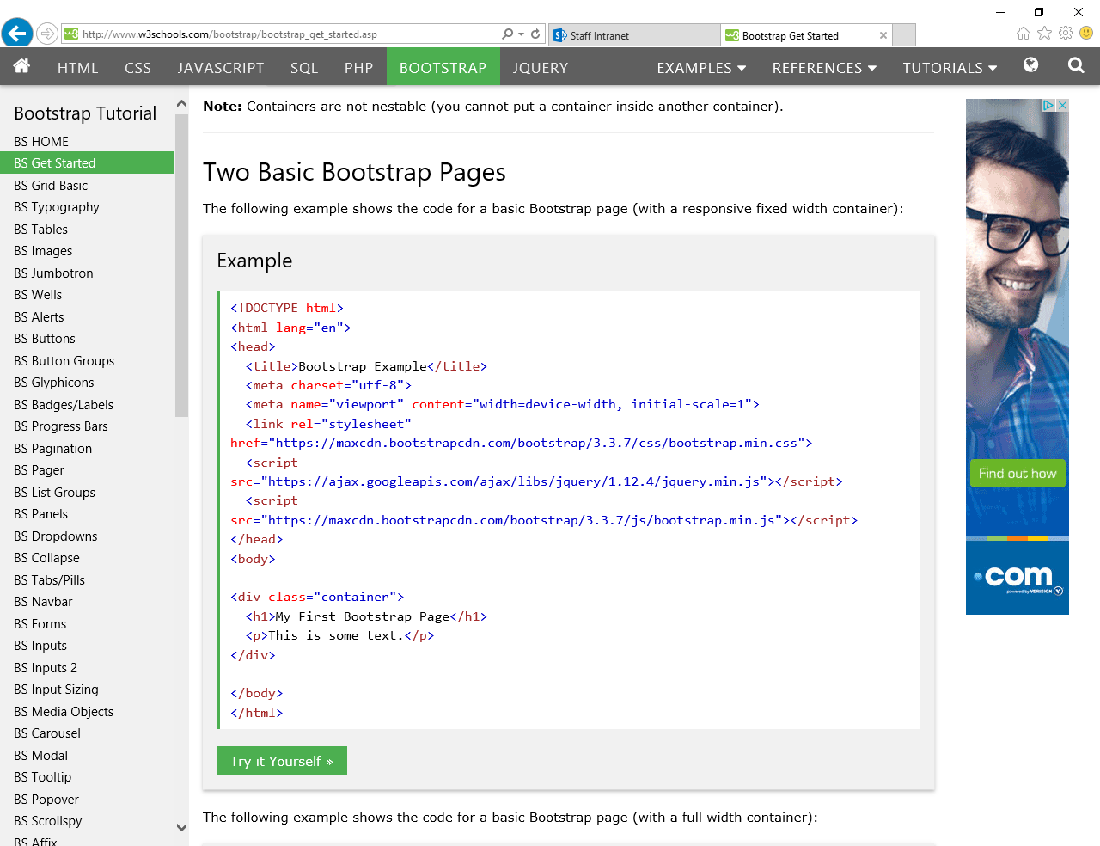

Paste this into your index page and it should look like the following:

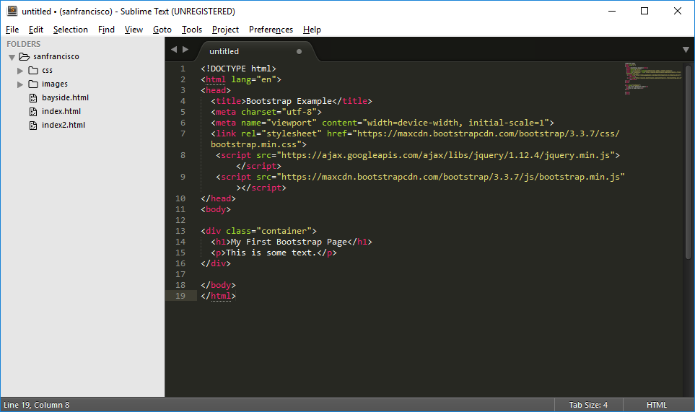

Within the code, make the following changes:

* Change the title to **Photography**
* Delete the h1 paragraph
* Delete the paragraph tag
* Save the page again and open in browser

**Adding a Jumbtron**

Highlight the text as shown and paste it inside the container tag

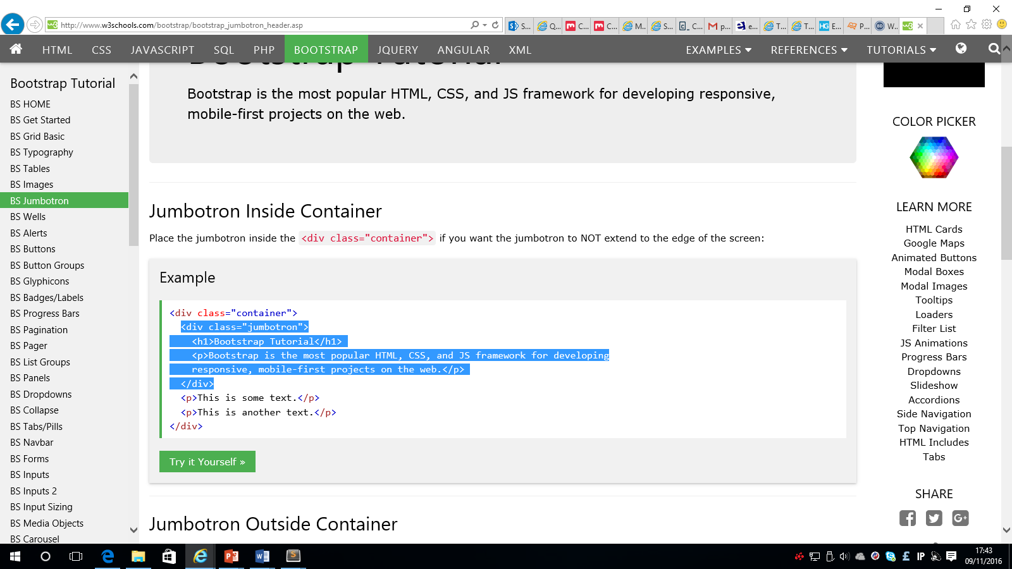

Change the code in the jumbotron so that it look like the following:

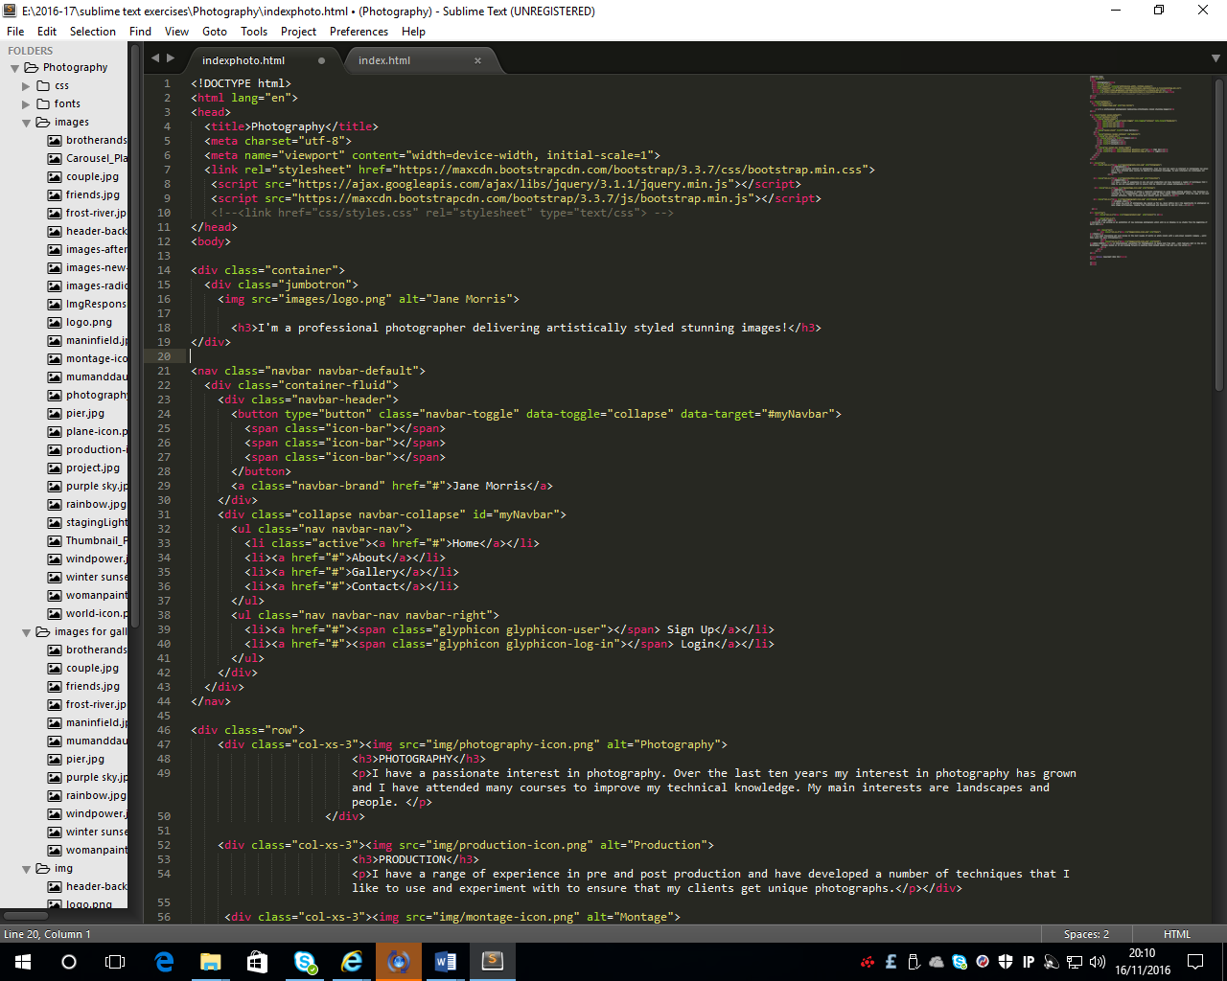

Save and open in browser

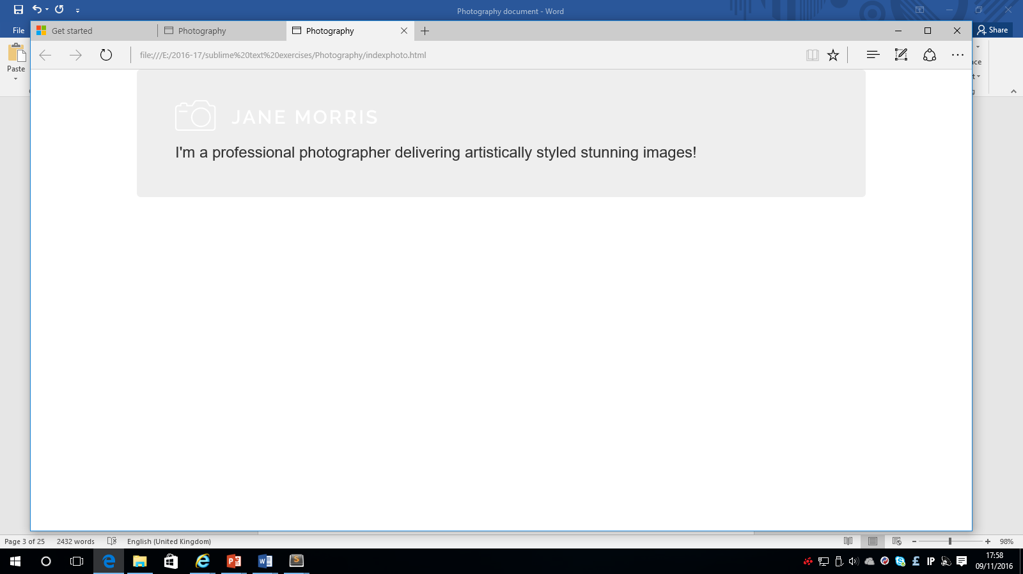

**Adding a Navigation bar**

Go back to w3 schools and select the BS Navbar. Find the following section and highlight the text between the nav tags

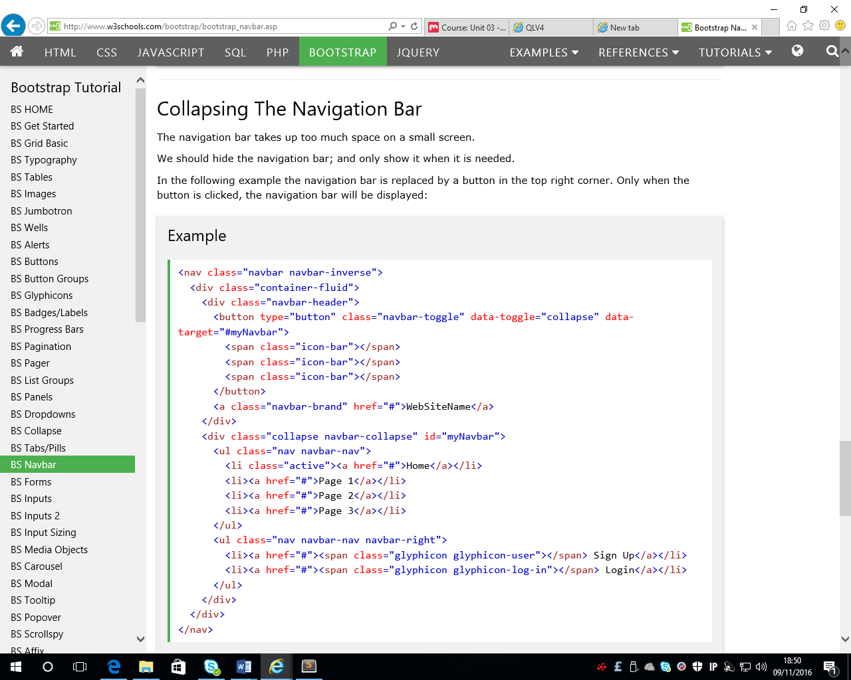

Paste this code directly after the jumbotron tag so the code looks like the following:

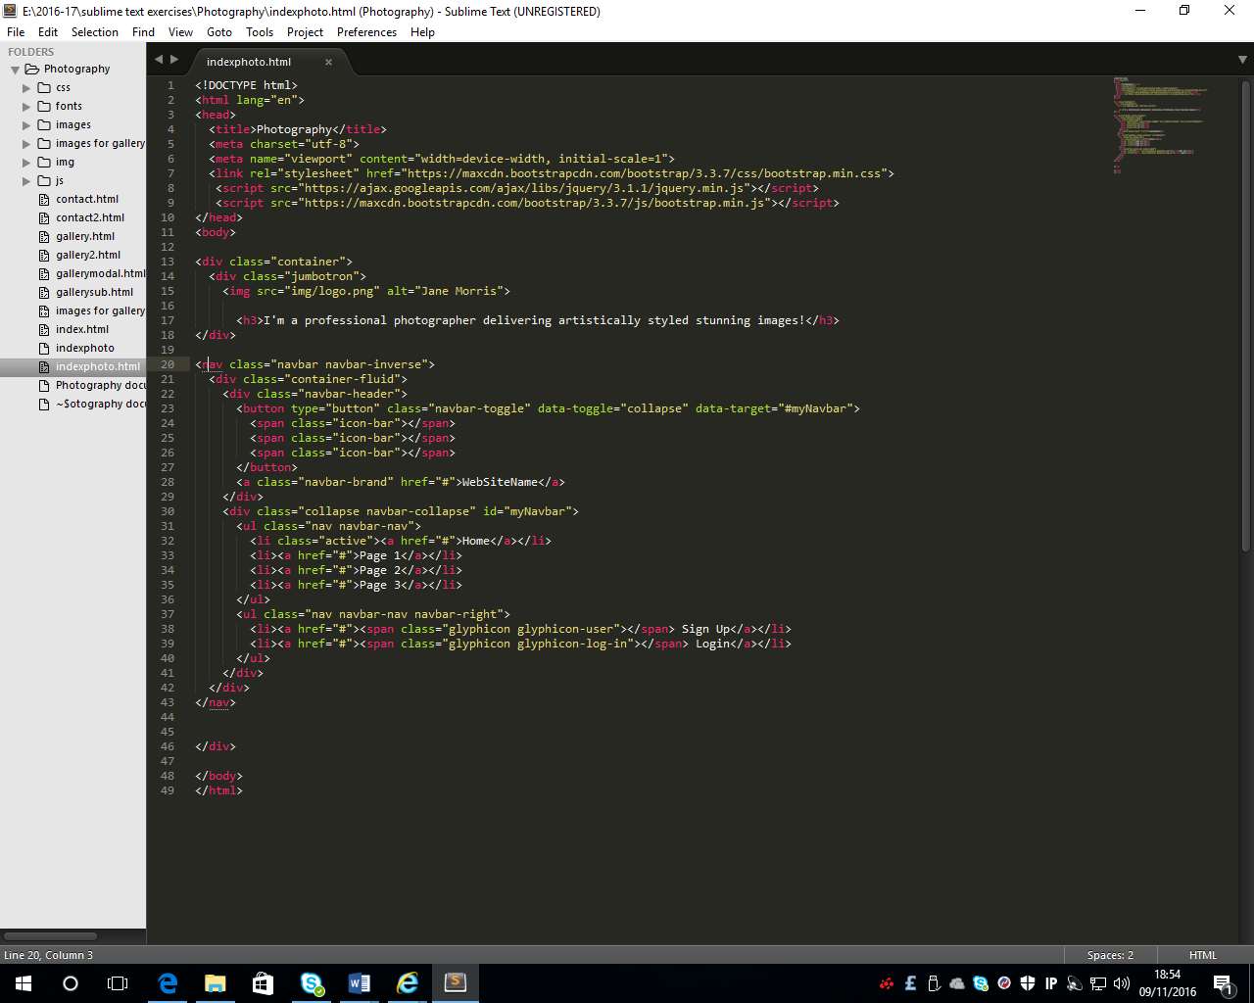

* Change the word **inverse** to **default**
* Change **Website Name** to **Jane Morris**
* Change **Page 1** to **About**
* Change **Page** **2** to **Gallery**
* Change **Page** **3** to **Contact** **Us**

Save the page and open in browser and it should look like this

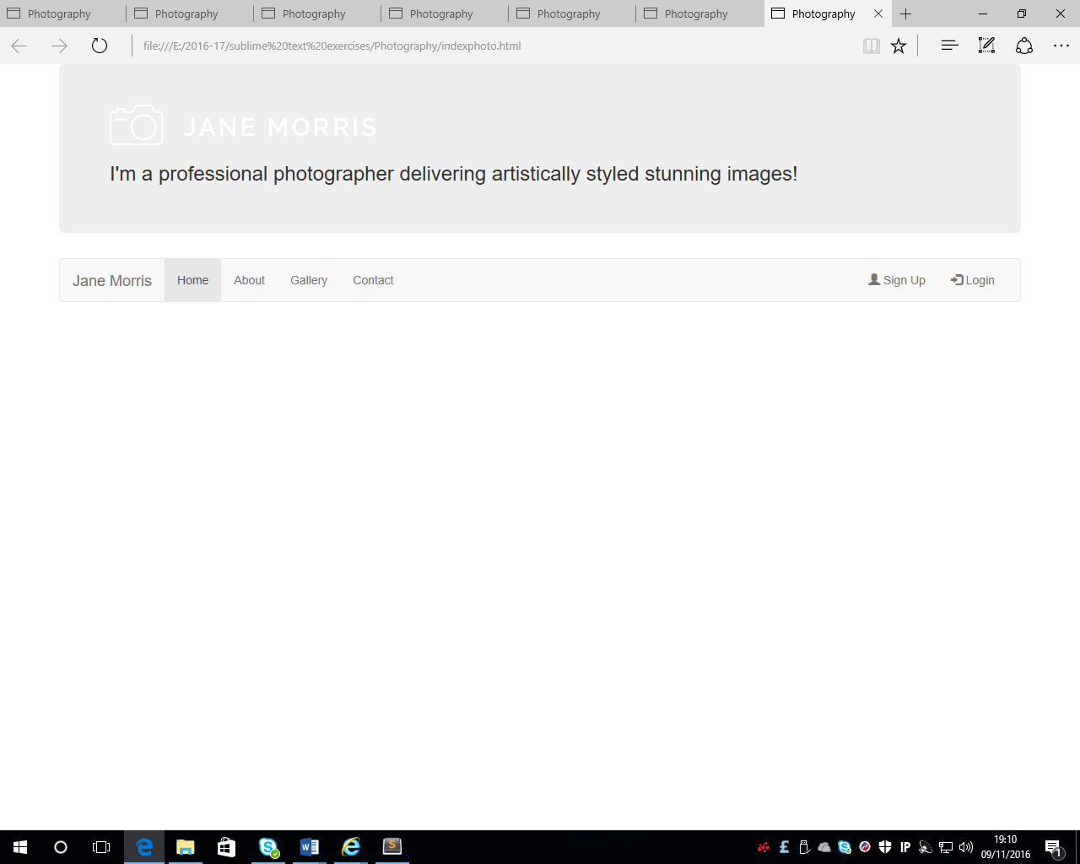

**Adding more layout**

Directly after the closing nav tag, enter the following code:

<div class="row">

<div class="col-xs-3"><img src="" alt="image1">

</div>

<div class="col-xs-3"><img src="" alt=" Image 1">

</div>

<div class="col-xs-3"><img src="" alt=" Image 1">

</div>

<div class="col-xs-3"><img src="" alt=" Image 1">

</div>

</div>

4 columns of equal width have been created. For each of the columns an image, heading 3 and some text will be added.

In the first column:

* add the image called photography-icon.png with the alt text of Photography
* a heading 3 called PHOTOGRAPHY
* paragraph text using the following - I have a passionate interest in photography. Over the last ten years my interest in photography has grown and I have attended many courses to improve my technical knowledge. My main interests are landscapes and people.

in the second column:

* add the image called production-icon.png with the alt text of Production
* a heading 3 called PRODUCTION
* paragraph text using the following - I have a range of experience in pre and post production and have developed a number of techniques that I like to use and experiment with to ensure that my clients get unique photographs.

In the third column:

* add the image called montage-icon.png with the alt text of Montage
* a heading 3 called MONTAGE
* paragraph text using the following - This is the technique of making a composite photograph by using image-editing software. This technique is referred to as "compositing", and in casual usage is often called "photoshopping" (from the name of the most popular software). This is becoming more popular with my clients.

in the fourth column:

* add the image called stagingLight-icon.png with the alt text of Staging Light
* a heading 3 called STAGING LIGHT
* paragraph text using the following - A whole new world of photography has opened up for me. Never before had I the opportunity to photograph so many stage performances, ranging from traditional and classical to pop and rock...

Save and open in browser. The page should look like the following:

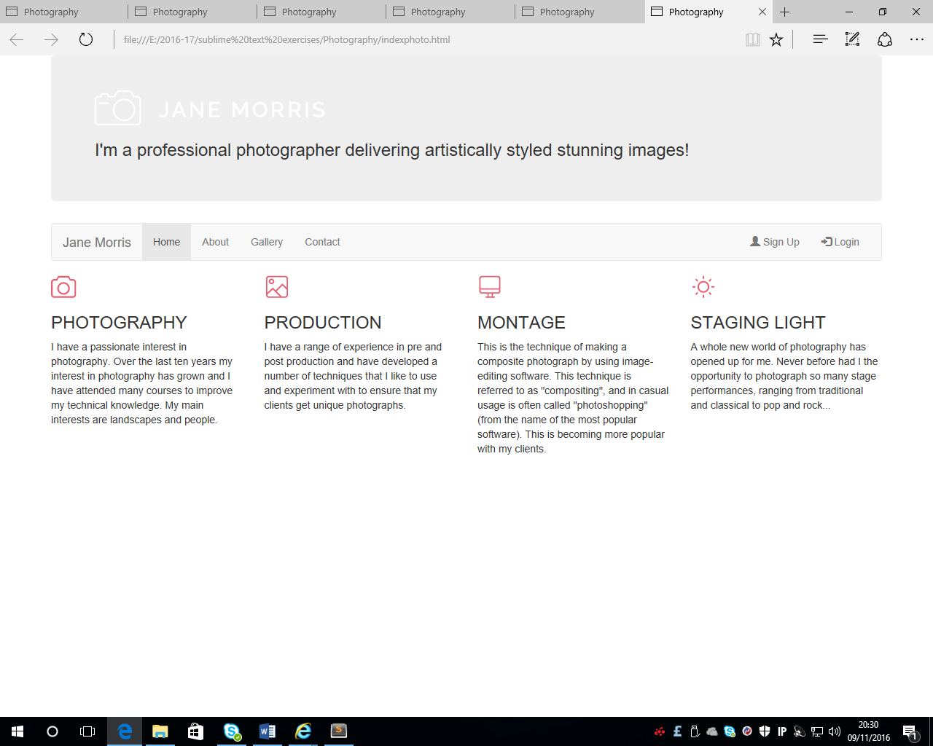

**Adding columns within a column**

Directly after the closing tag for the row, add the following code:

<div class="row">

<div class="col-xs-6"><img src="" alt=""/> </div>

<div class="col-xs-6">

<div class="row">

This is another row with 2 columns inside the second column that is 6 wide. These columns that have been added are also 6 wide each

<div class="col-xs-6"><img src="" alt="">

</div>

<div class="col-xs-6"><img src="" alt="">

</div>

</div>

</div></div>

Insert the alt text Project

Insert the image called project.jpg

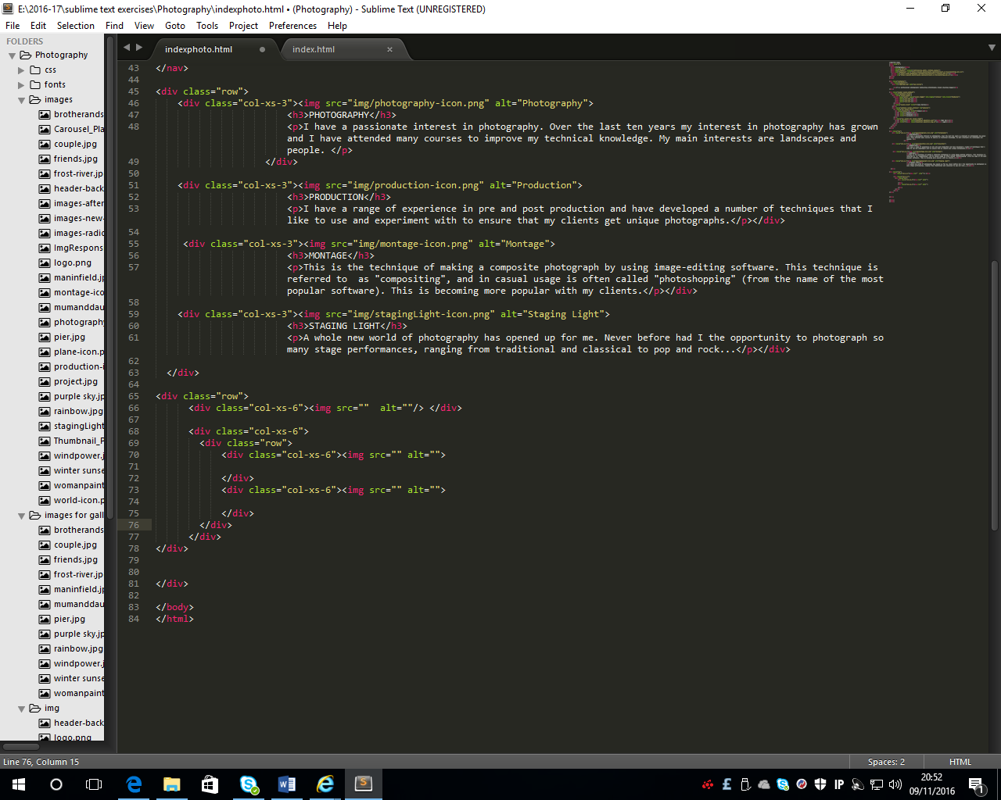

Enter an image called world-icon.png with the alt text World.

Also add a heading 4 WORLD EVENTS and paragraph text using the following – An international convention for Photographers is being held from 25th – 26th February 2017 in the NEC in Birmingham. Already booked on it and looking forward to meeting liked minded people from all over the world

Enter a heading 3 called MY LATEST WORK and

paragraph text using the following – Currently I am working on an exhibition of new landscape photographs which will be on display in my studio from the beginning of March 2017.

Enter an image called plane-icon.png with the alt text Plane.

Also add a heading 4 TRAVEL and paragraph text using the following – I have been travelling all over Europe in the last couple of months on photo shoots with a well-known cosmetic company – watch this space for more information!

**Adding a footer**

After the code for the columns add the following:

<footer>&copy; Copyright 2016 JM</footer>

Make sure that it is inside the last </div> tag

Save the index.html page and open in browser. It should look like the following:

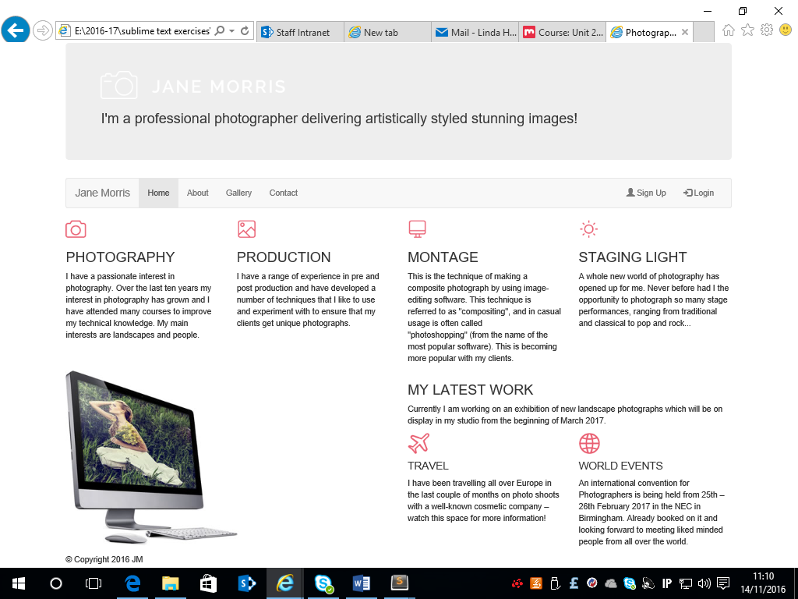

**Adding some styling using CSS**

* Create a new page and save it as **styles.css**.
* Place the appropriate code in the head tag of the index.html page to link to this style sheet
* Text has been added beside the code to explain what the code is doing. Include this text as comments in the styles.css page

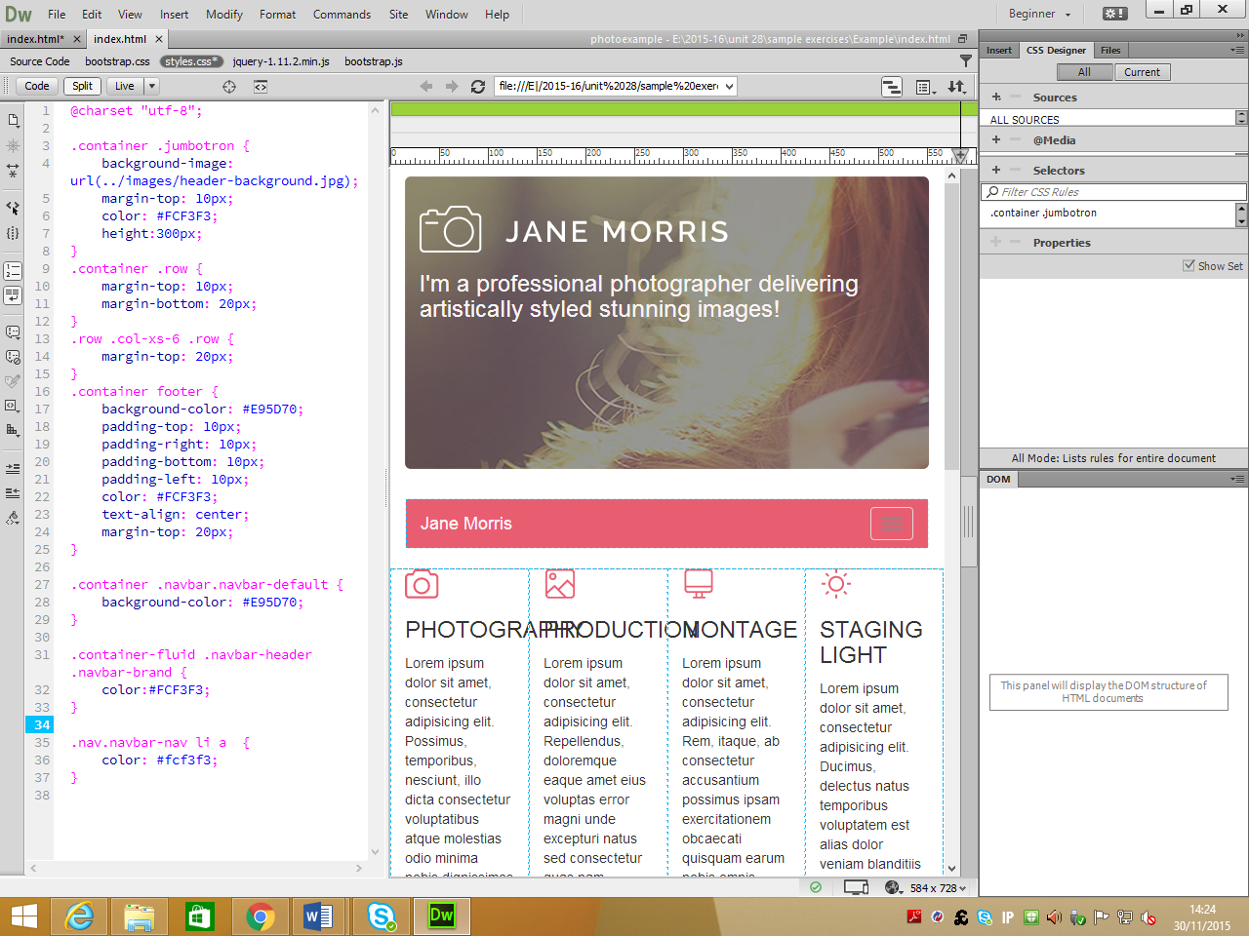

Sets the colour of the navigation links

Sets the background colour of navigation bar

Sets the background colour of the active link

This is the code to put some spaces around the text and align it to the centre

This is the code to put some margins and help the layout

This is the code to put a background image, put margins and specify a height for the jumbotron

The index.html page should now look like the following:

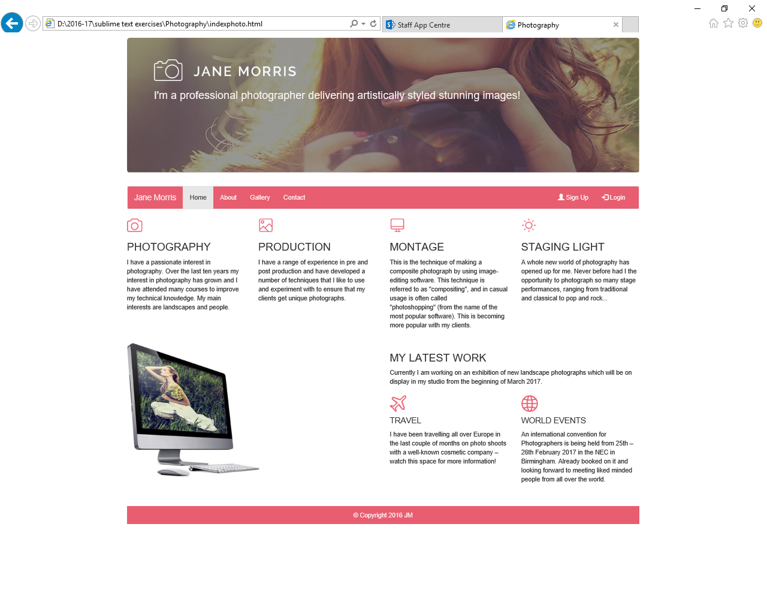

**Adding the Navigation links to the main menu options**

* Home - add the link index.html
* About - add the link about.html
* Gallery - add the link gallery.html
* Contact - add the link contact.html

Save the index.html page and check the links are working.

**Creating the about.html page**

With the index.html page open, select save as and save the page as **about.html**

Remove the code so that only the header, navigation and footer remains. When opened in the browser, the page should be displayed as follows:

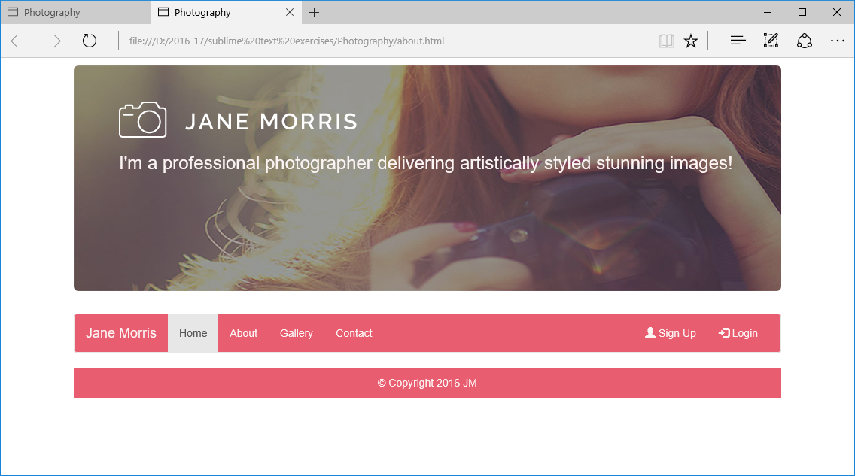

**Creating the gallery.html page and the contact.html page**

Make sure the about.html page is open and select the save as option.

* Save the page as **gallery.html** and then
* Save the page as **contact.html**

All the pages are now created. Move the active class in the **about.html**, **gallery.html** and the **contact.html** as appropriate.

**Adding layout to the gallery.html page**

After the navigation and before the footer tag, enter the following code:

<div class="row">

<div class="col-xs-12">

<div class="col-md-2">

<div class="thumbnail"><img src="" alt="image 1">

<div class="caption"> <h5> text</h5></div>

</div>

</div>

</div>

</div>

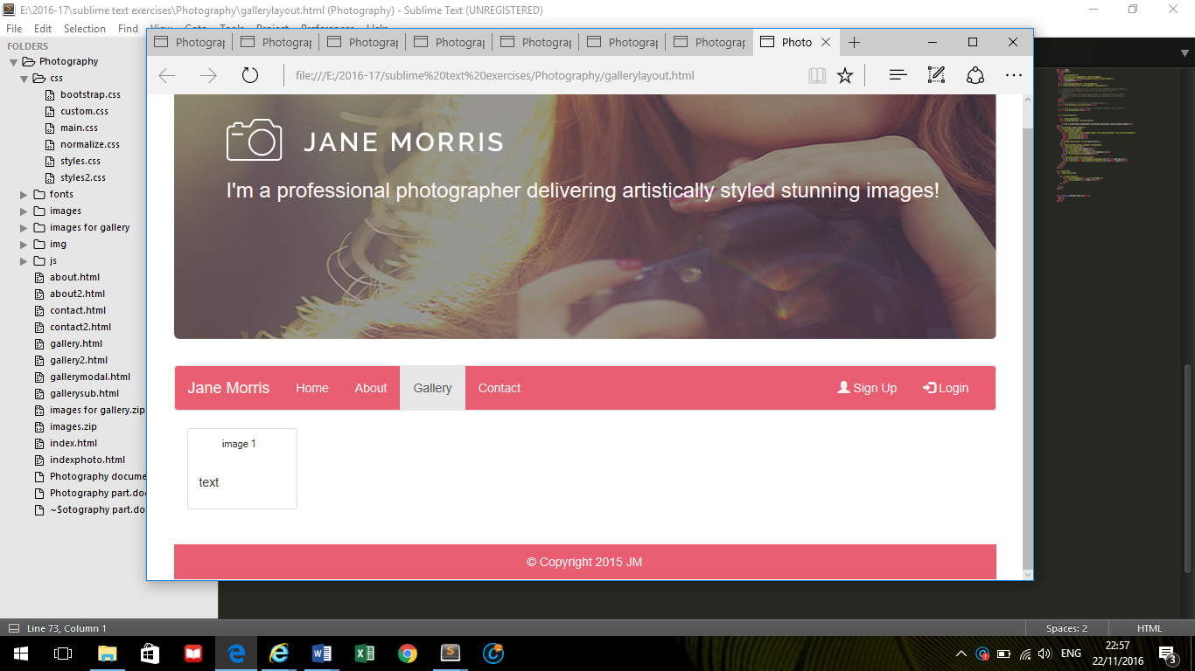

Add the following:

* image called **winter sunset.jpg**
* alt text **winter sunset**
* caption text **winter sunset**

The code will look like the following:

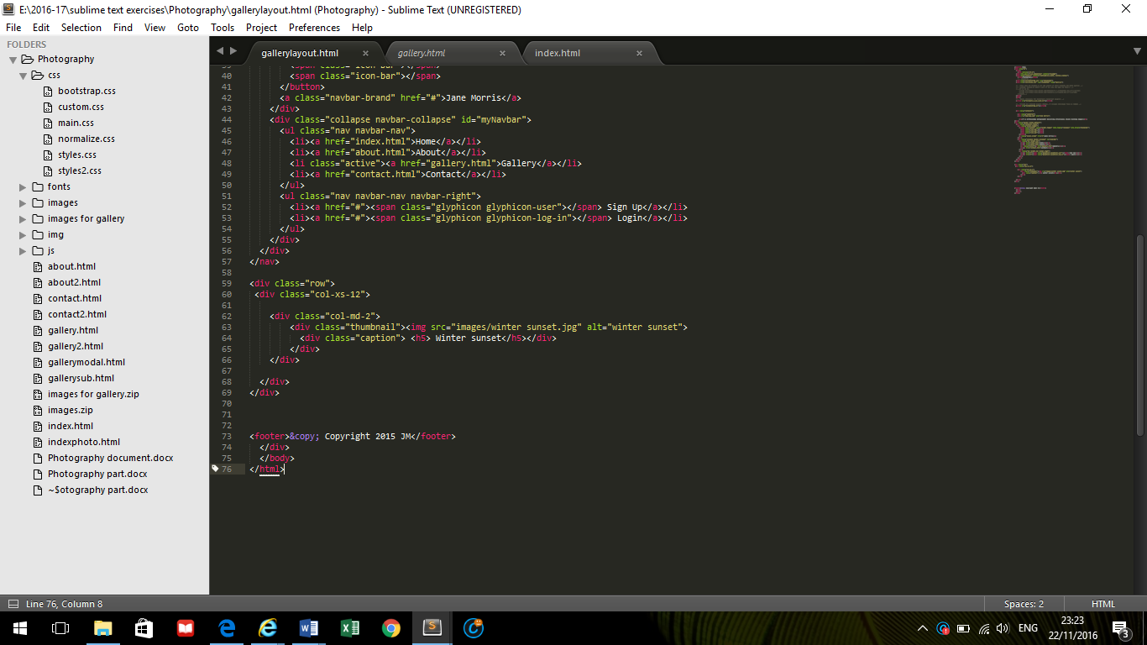

Save the page and open in the browser

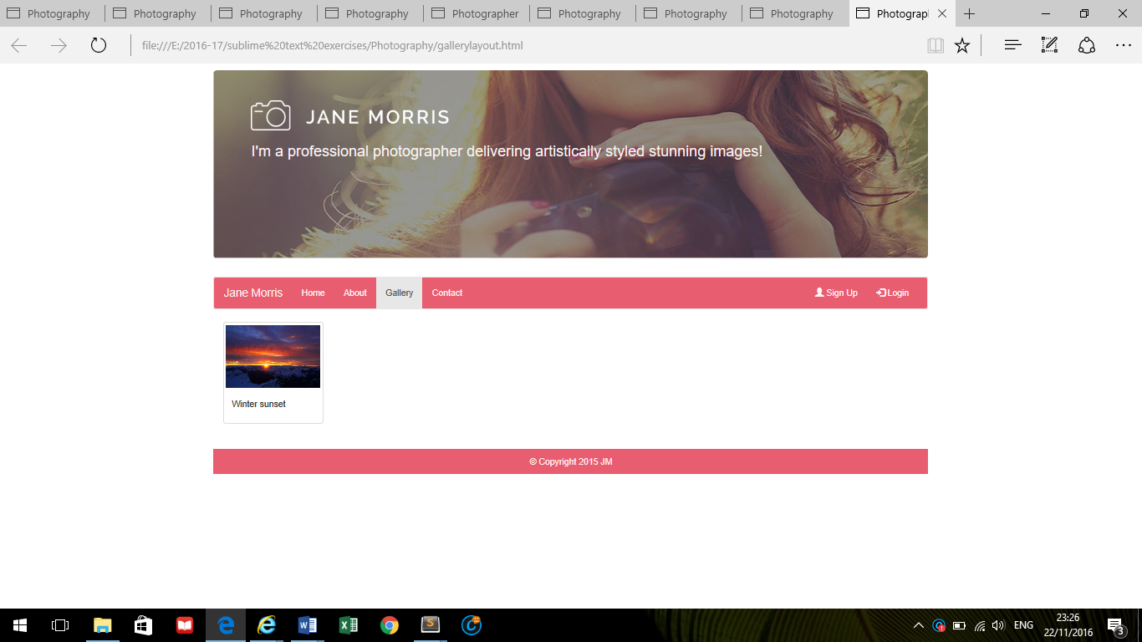

Another 5 images will be added so that 6 images in total will be displayed in a row.

Looking at the existing code again. The following changes will be made:

Enter a heading 2 called Landscapes and paragraph text using the following – I enjoy regularly supplying imagery and undertaking commissions for a wide range of business clients. I have photographed five of the seven continents. Below is a sample of some landscapes that have been taken in the last year.



Copy the code outlined in red and paste in here

The code now looks like the following:

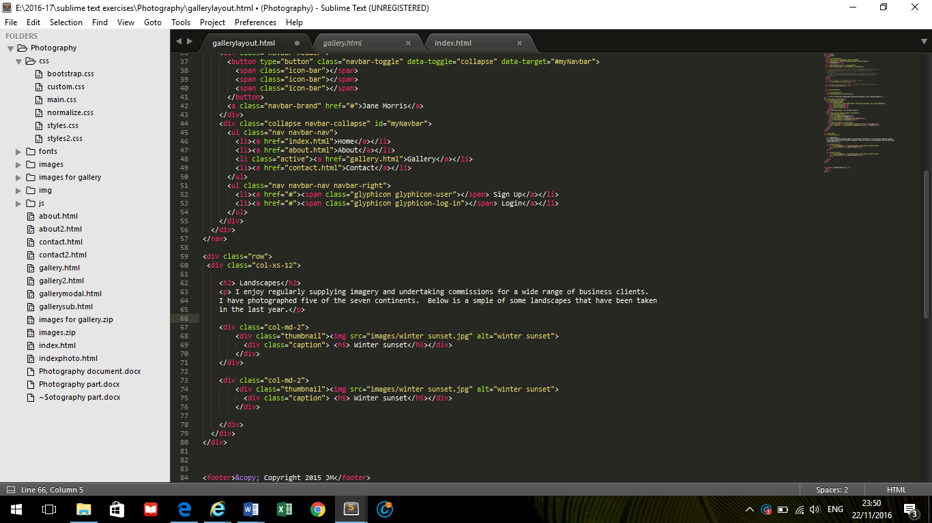

Repeat this copy and paste until 6 images have been added. Save the page and open in the browser

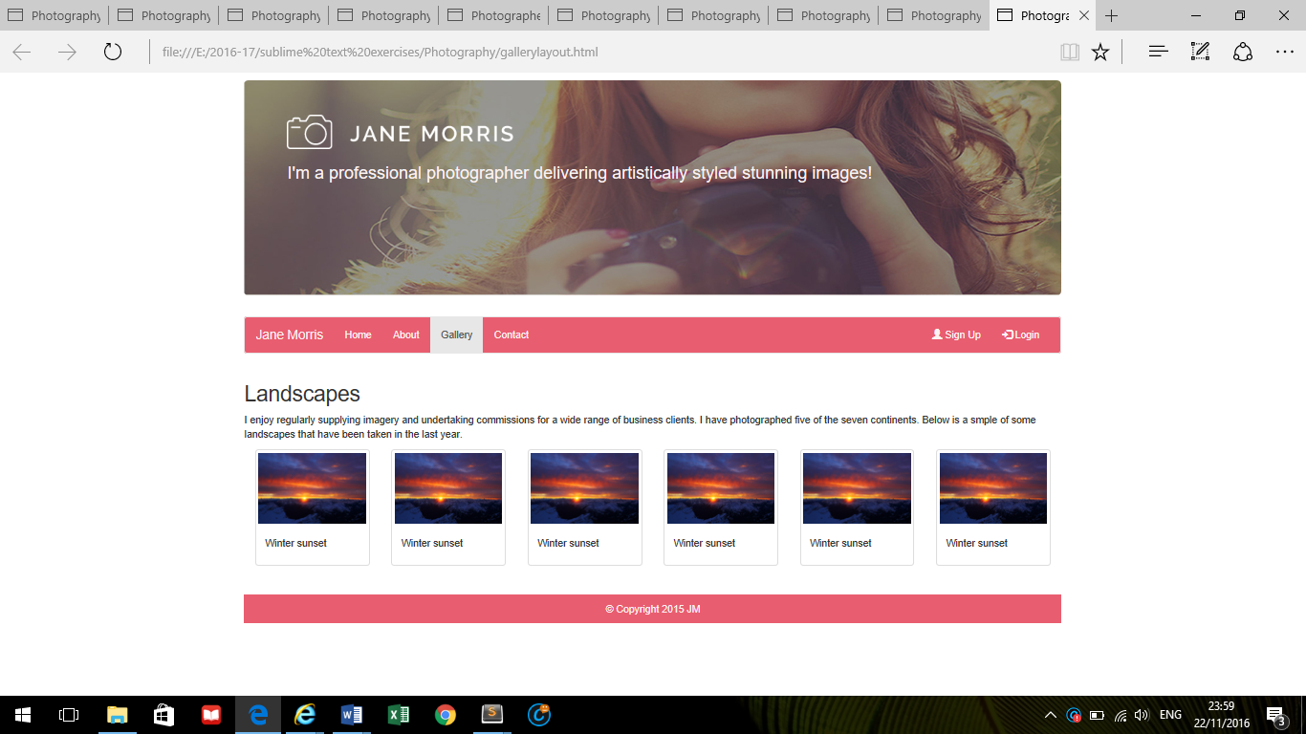

Changes the images and text for the 2nd to the 6th images

2nd image:

frost-river.jpg, alt text=frost on the river, caption - frost on the river as h5

3rd image:

rainbow.jpg, alt text=rainbow, caption - Rainbow as h5

4th image:

purple sky.jpg, alt text= purple sky, caption - Purple sky as h5

5th image:

windpower.jpg, alt text= wind power, caption – Wind power as h5

6th image:

pier.jpg, alt text= Pier, caption – On the pier as h5

The code should look like the following:

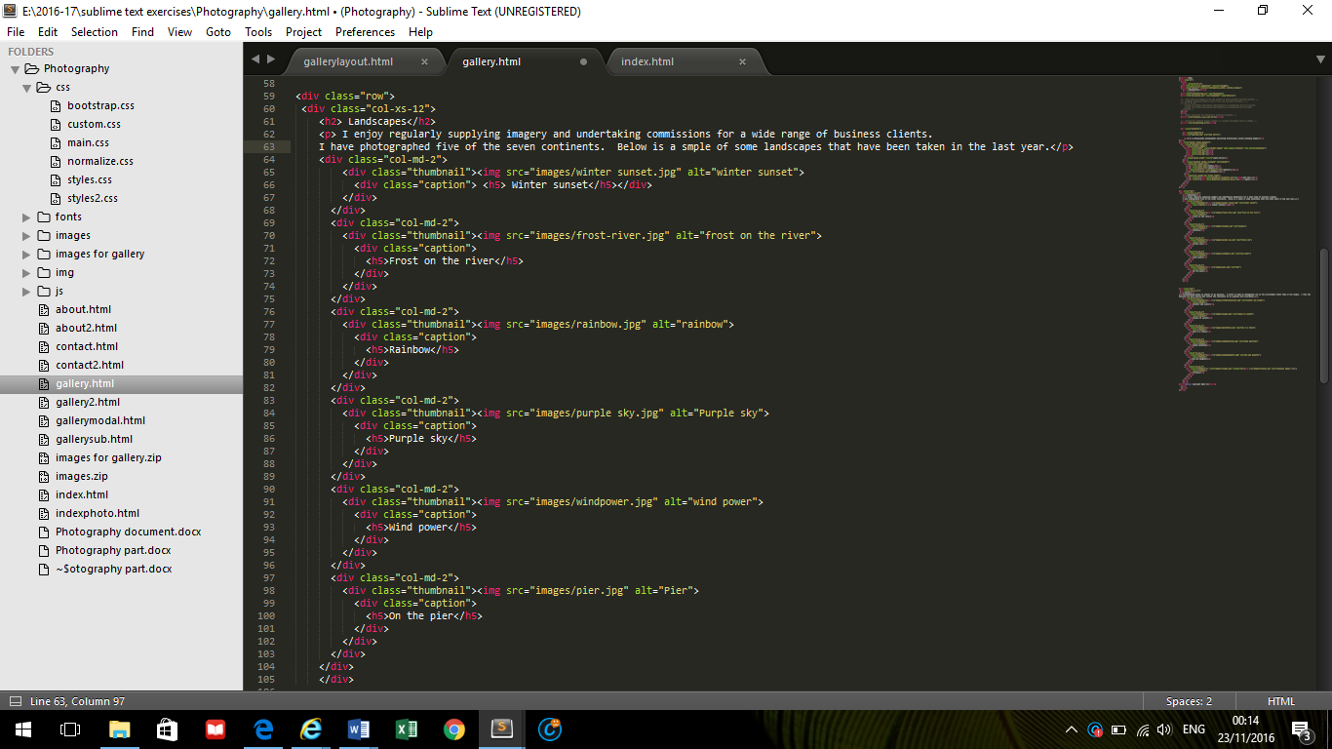

Open the page in the browser and it should look like the following:

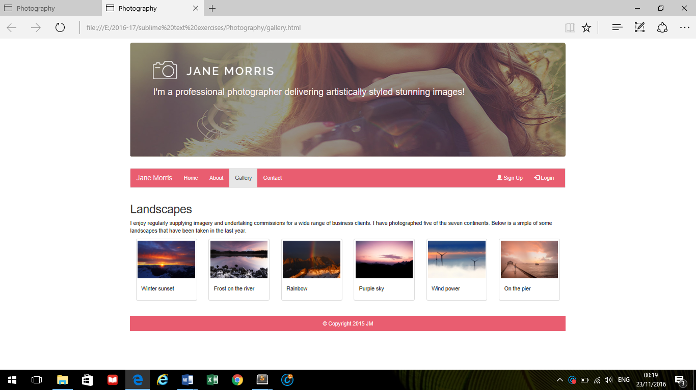

Next is adding the images for the people gallery.

This will involve:

* copying the code for the Landscapes section
* pasting it directly below the Landscapes section and before the footer
* changing the text and images

The code needed for copying is shown below:



Paste this copied code directly beneath the code that has just been copied.

The page should look like the following:

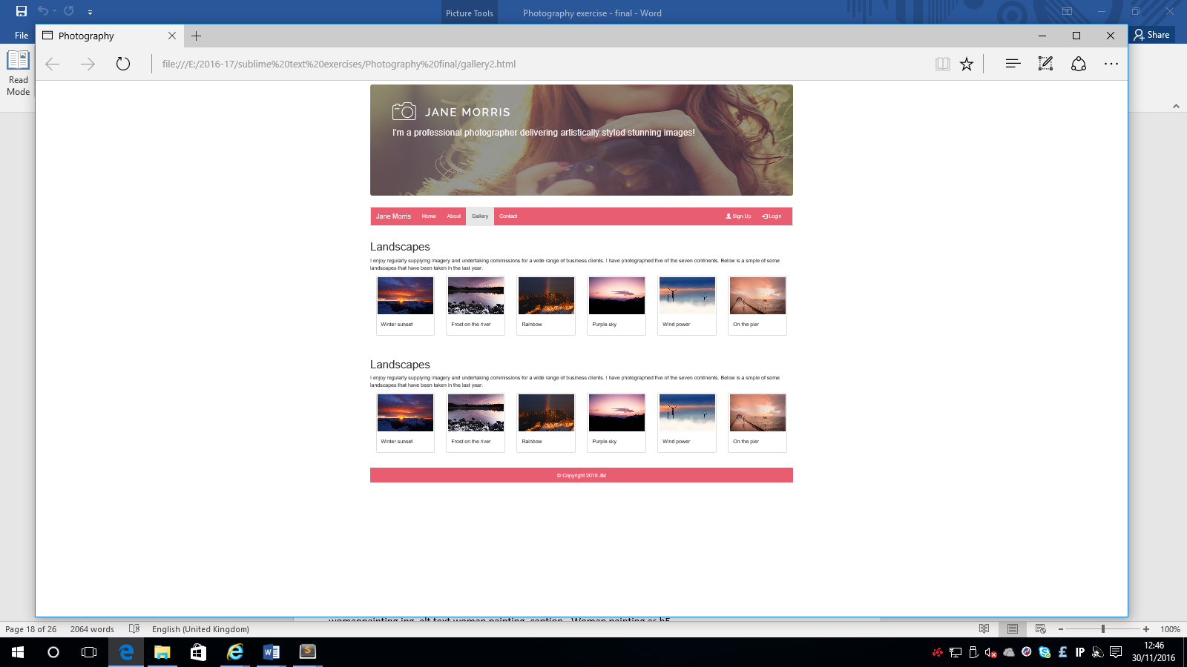

Make the following changes:

Replace the heading 2 **Landscapes** with **People** and the paragraph text under the heading Landscapes with the following:

* Another passion is photographing people. I enjoy taking the photographs out in the environment rather than in the studio. I believe that this helps to capture the personality of the subject. Below are some pictures from a recent photoshoot.

Changes the images and text for the 1st to the 6th images

1st image:

brotherandsister.jpg, alt text=brother and sister, caption – Brother and sister as h5

2nd image:

couple.jpg, alt text= couple at sunset, caption - Couple at sunset as h5

3rd image:

maninfield.jpg, alt text= Man in a field, caption - Man in a field as h5

4th image:

womanpainting.jpg, alt text woman painting, caption - Woman painting as h5

5th image:

mumanddaughter.jpg, alt text= mum and daughter, caption – Mum and daughter as h5

6th image:

friends.jpg, alt text= friends , caption – Friends as h5

Save the page and open in browser. The gallery page should be displayed as follows:

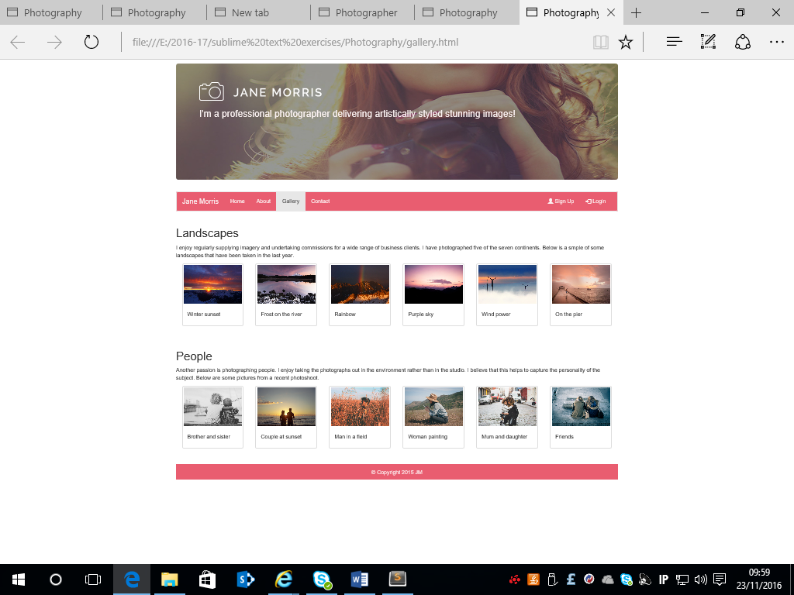

**Adding layout to the about.html page**

After the navigation code and before the footer code, copy and paste the following code:

<div class="row">

<div class="col-xs-6">

</div>

<div class="col-xs-6">

</div>

</div>

Go to w3 schools bootstrap and select the JS Carousel option. Then scroll down to this section

Scroll down until you find the following section:

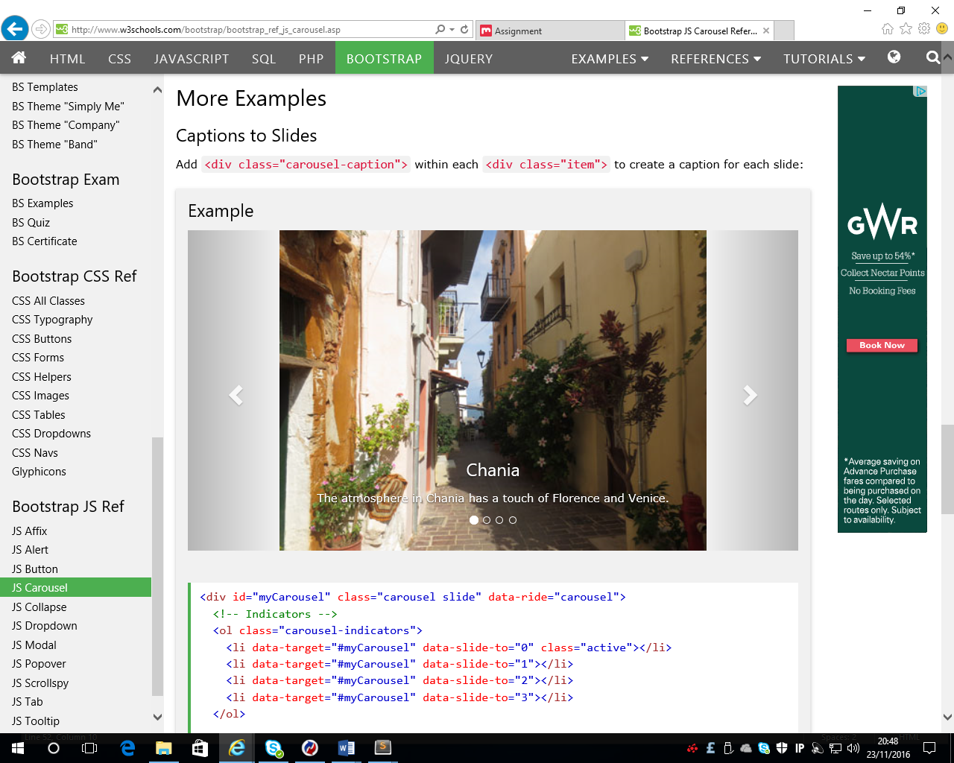

In this section highlight all the code and copy it. Paste this code here before the </div>

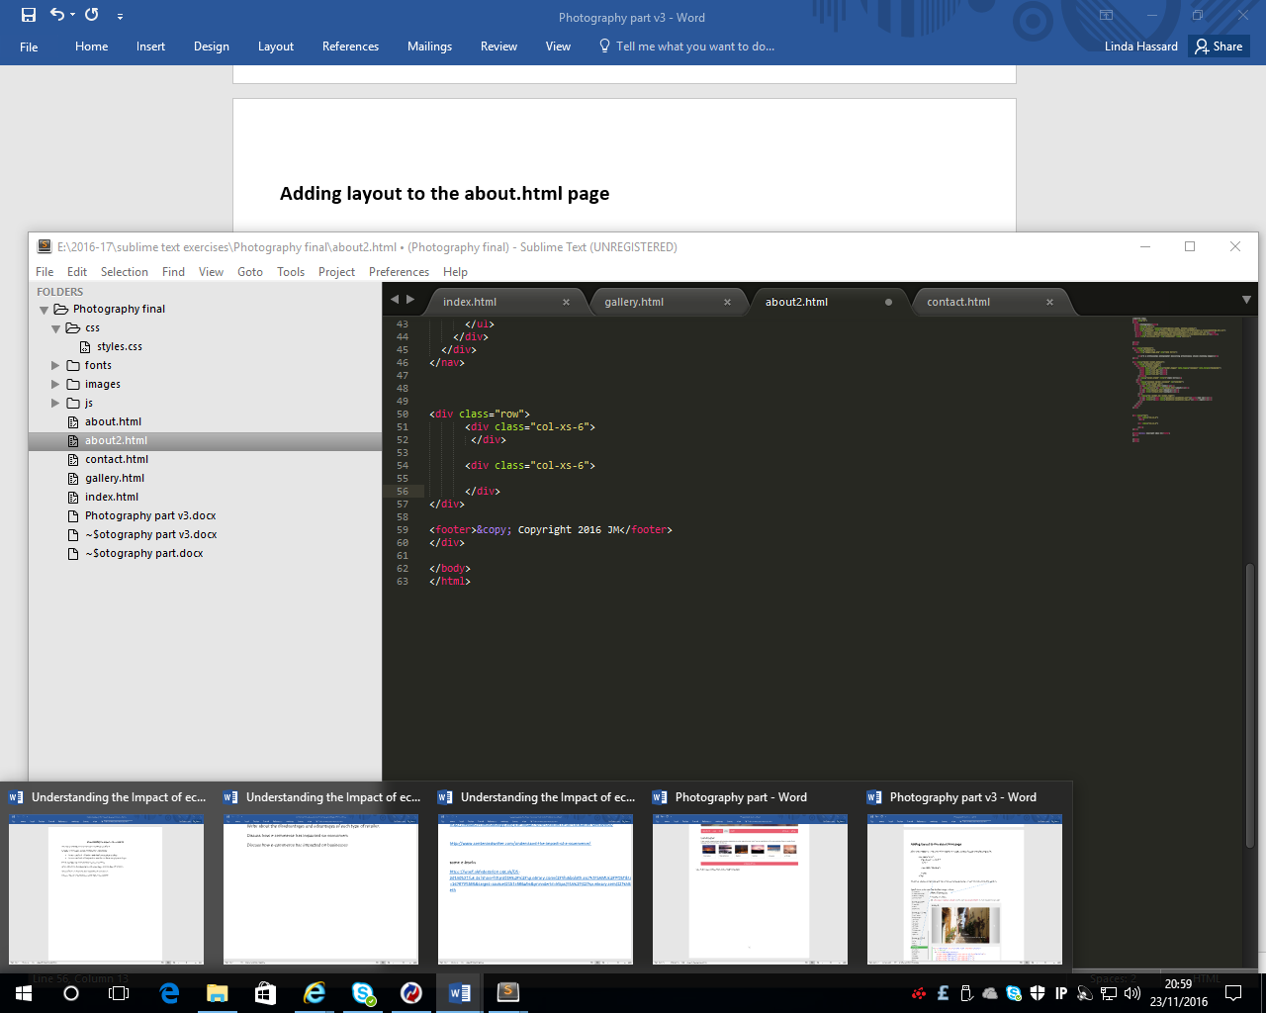

Save the page and open in browser

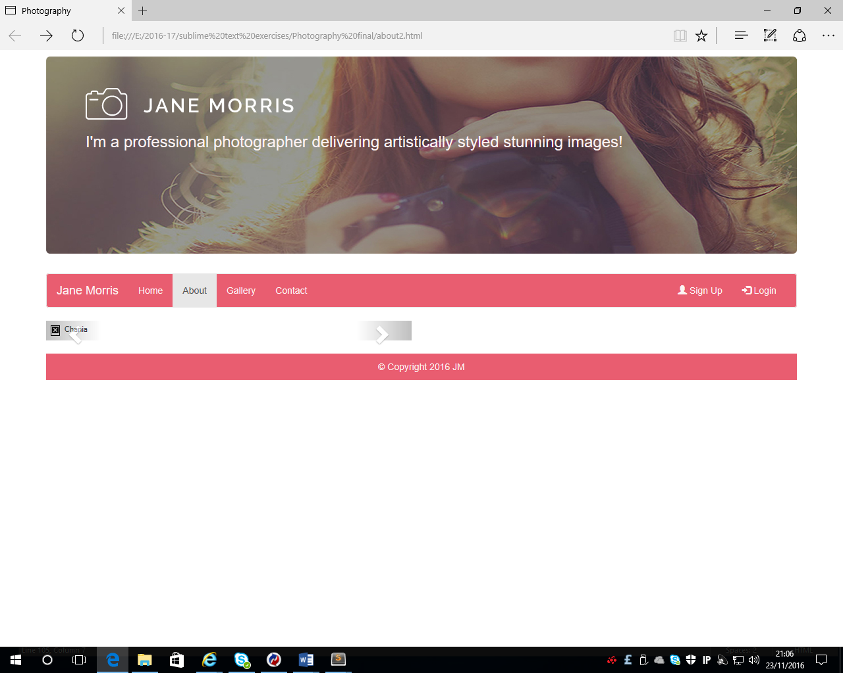

The carousel has been added but the default images aren’t displayed. The next step is to replace these images with some images from the images folder.

Find the following code:

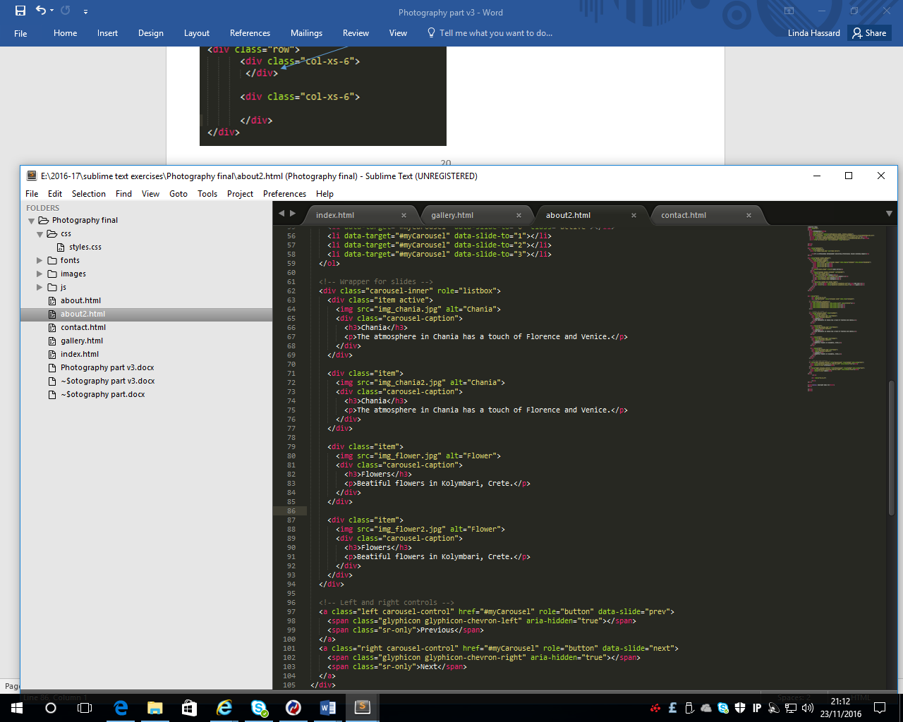

and replace the images, h3 text and the paragraph text with the images, h3 text and paragraph text that is shown below

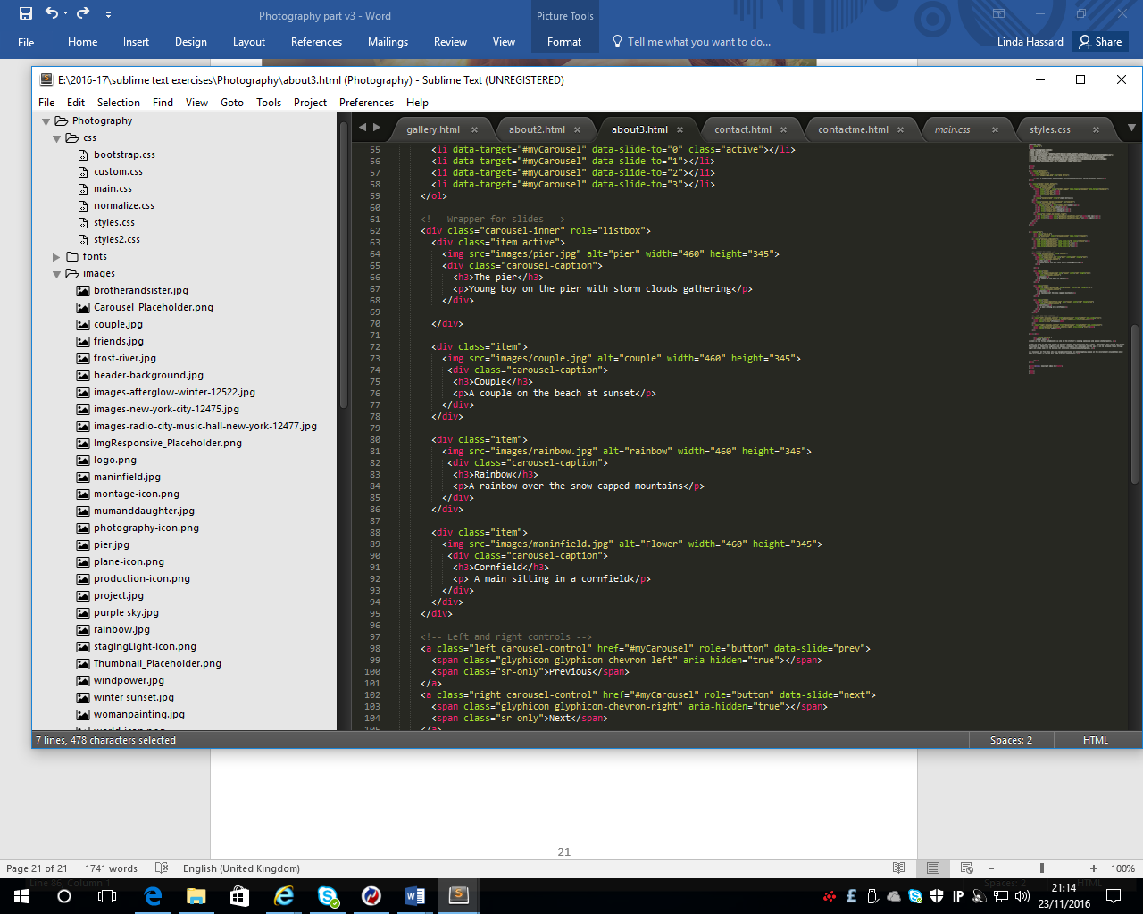

Add the following code to the style.css

.carousel-inner > .item > img

{

width: 100%;

margin: auto;

}

Save the page and preview in browser. It should look similar to the following:

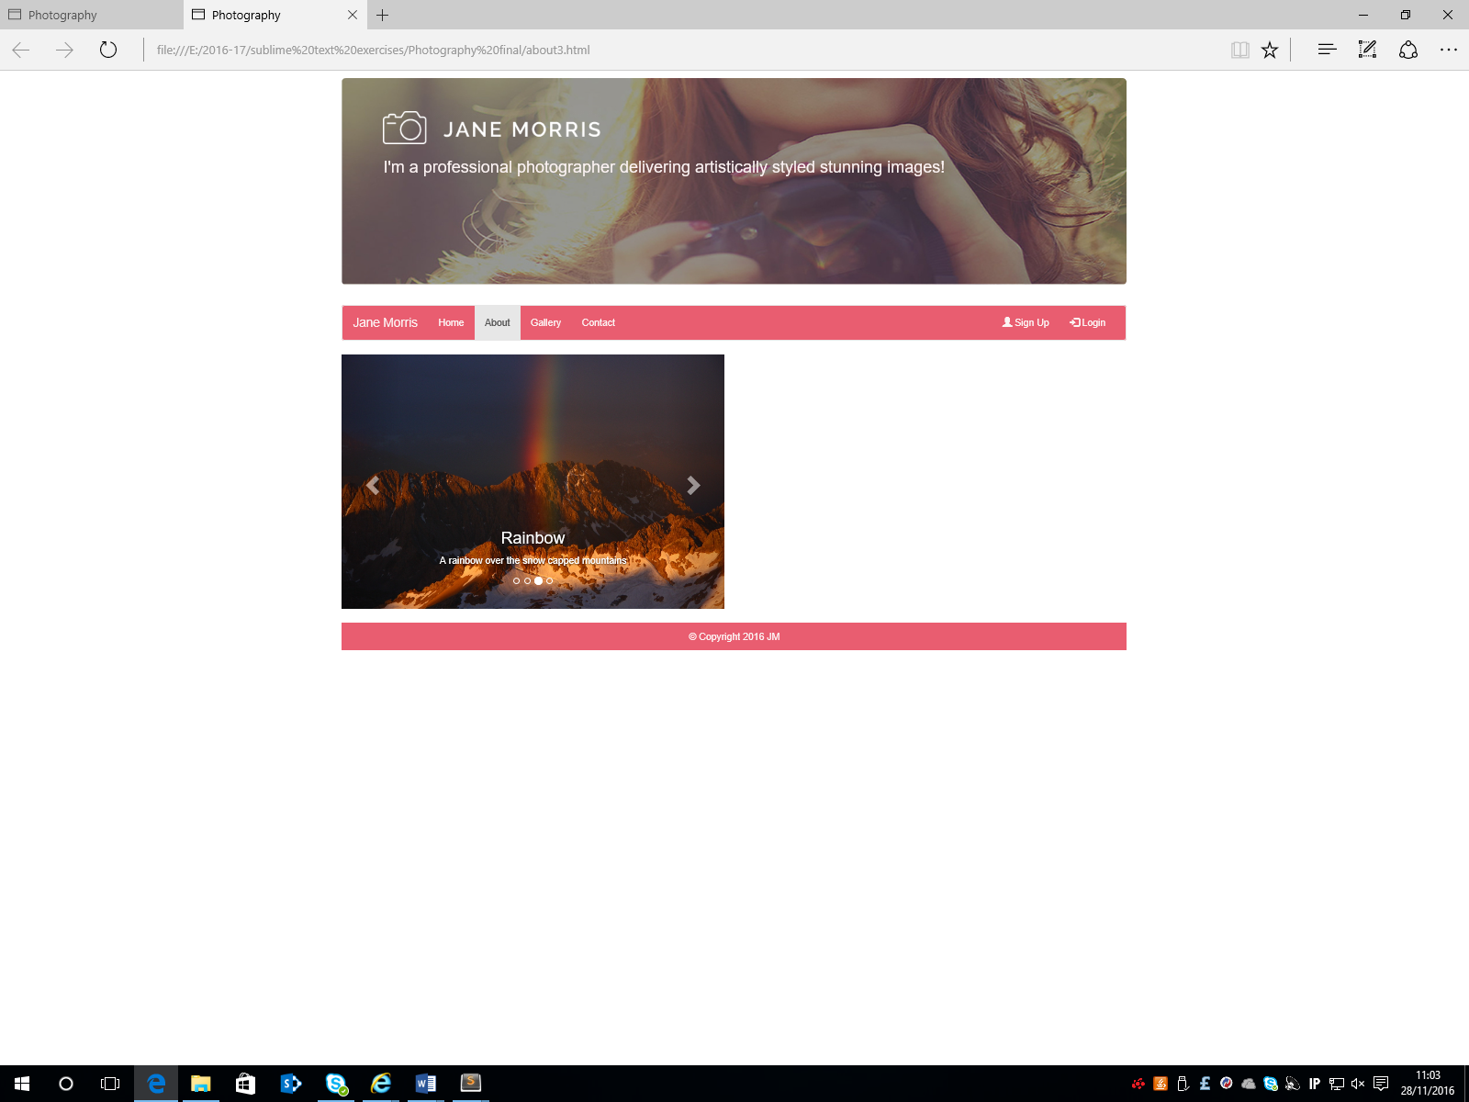

The slideshow should automatically scroll through the images. The screenshot above shows the 3rd image in the sequence.

Go back to the code and find the following section. This is after the code entered for the carousel and is the 2nd column that was entered initially on this page.

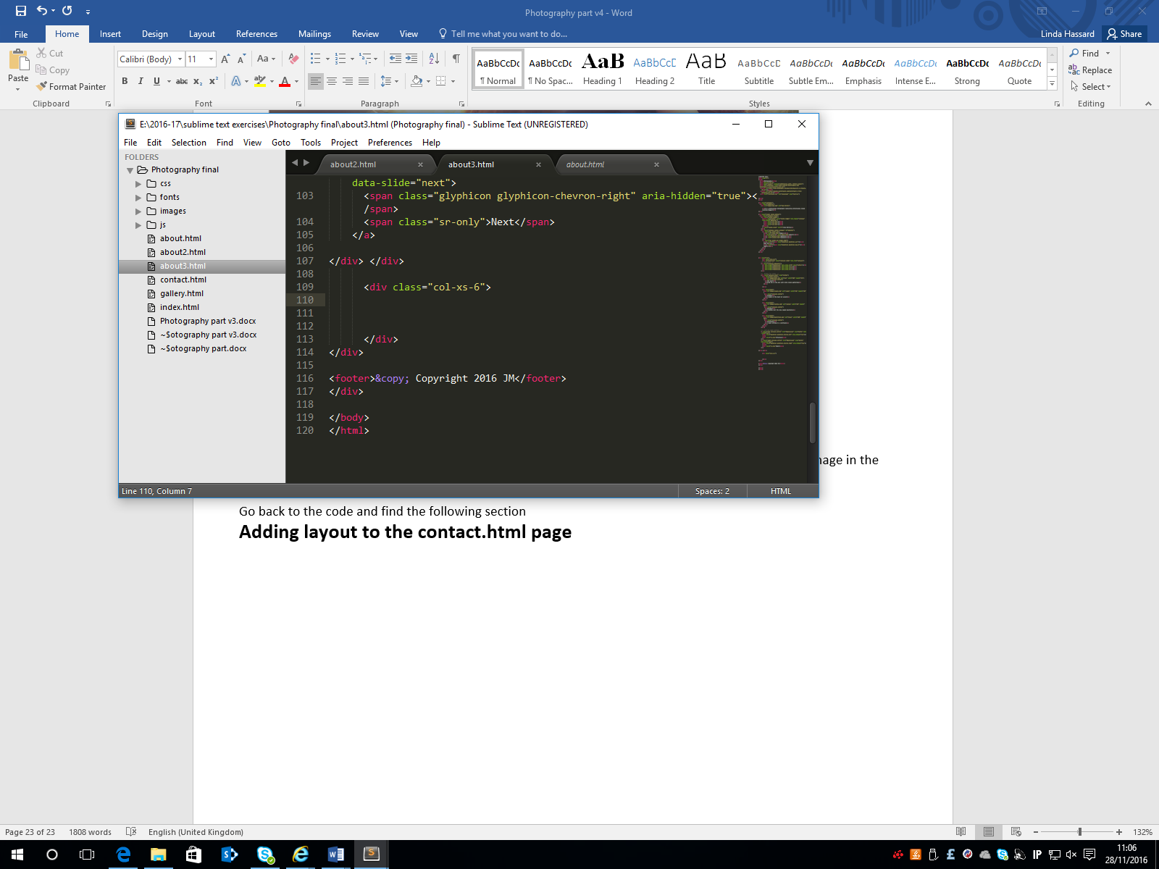

Into this add the following text

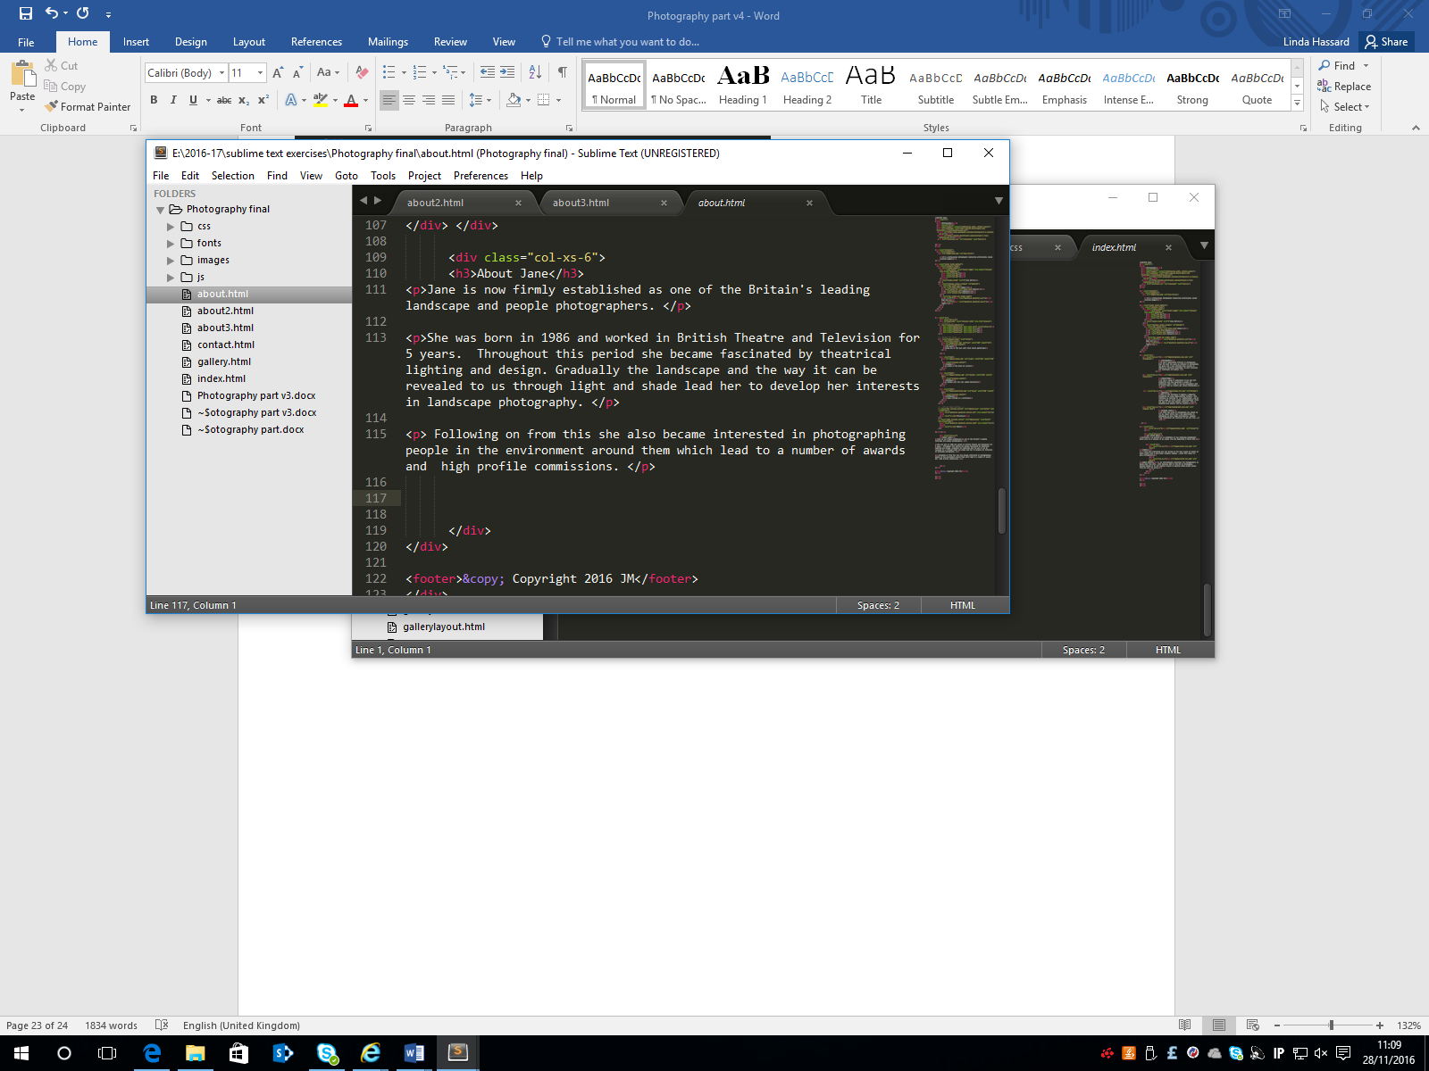

Save the page and open in the browser. The page should look like the following:

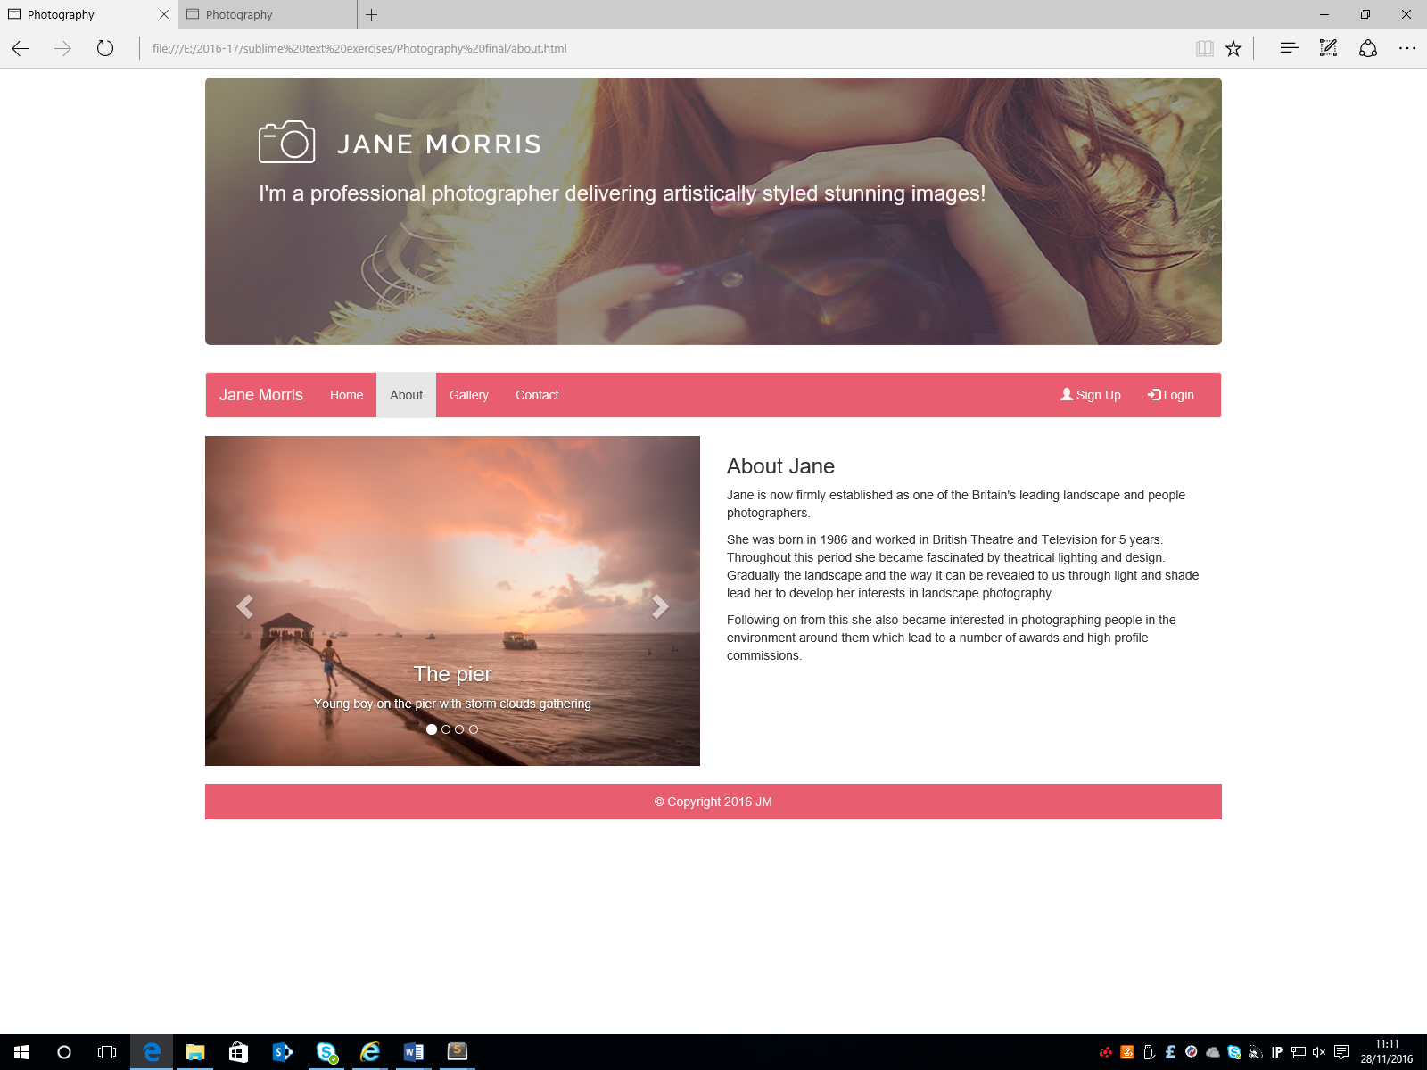

**Adding layout to the contact.html page**

This contact page is similar to the one that was used in the Bayside exercise. After the navigation code and before the footer code, copy and paste the following code:

<div class="row">

<div class="col-sm-5">

</div>

<div class="col-sm-7">

</div>

</div>

Save your page. The 2 columns that have been entered are different sizes. In the **first column (column size 5),** paste the following code:

<h3>Contact Details</h3>

<p>Contact me and I will get back to you as soon as possible</p>

<p><span class="glyphicon glyphicon-map-marker"></span> Lisburn, Northern Ireland</p>

<p><span class="glyphicon glyphicon-phone"></span> +0044 628354</p>

<p><span class="glyphicon glyphicon-envelope"></span> janemorris@gmail.com</p>

In the **second column (column 7),** paste the following code **:**

<div class="map-responsive">

</div

In between these tags, the code for the map will be inserted

* Go to google maps and search for **Lagan Valley Island Lisburn**
* Click **Share** and then **embedded** map
* Select **small** or **medium** size
* Copy the copy and paste the code
* In the code that has been copied, change the width to 95%

If unsure about these steps, see the screenshots in the Bayside exercise.

Save and open in the browser

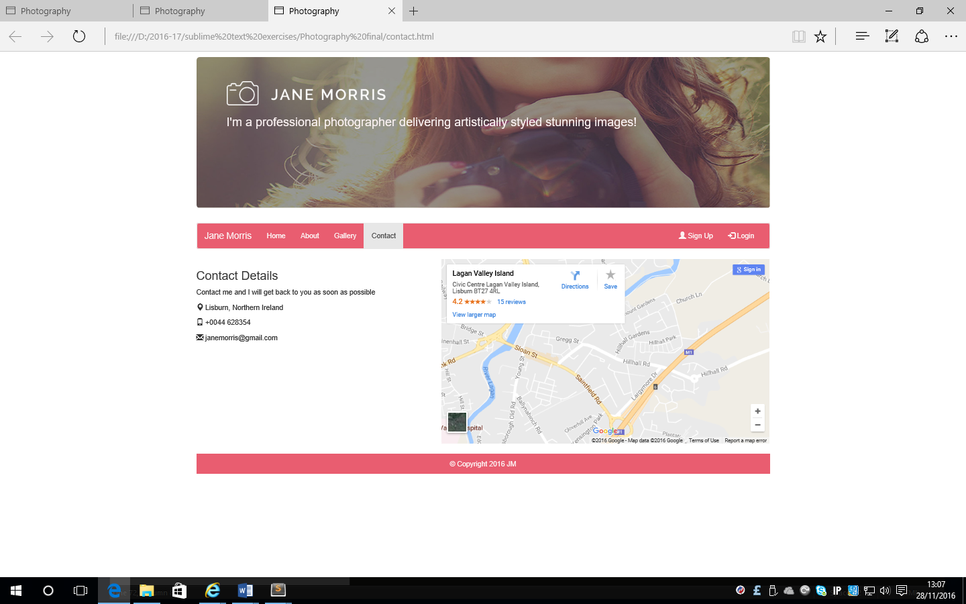

All 4 pages have now been created. Test that all the links, images and text are working/displayed correctly.